## Exp. 1

## Design a LED FLASHER

Circuit Diagram:

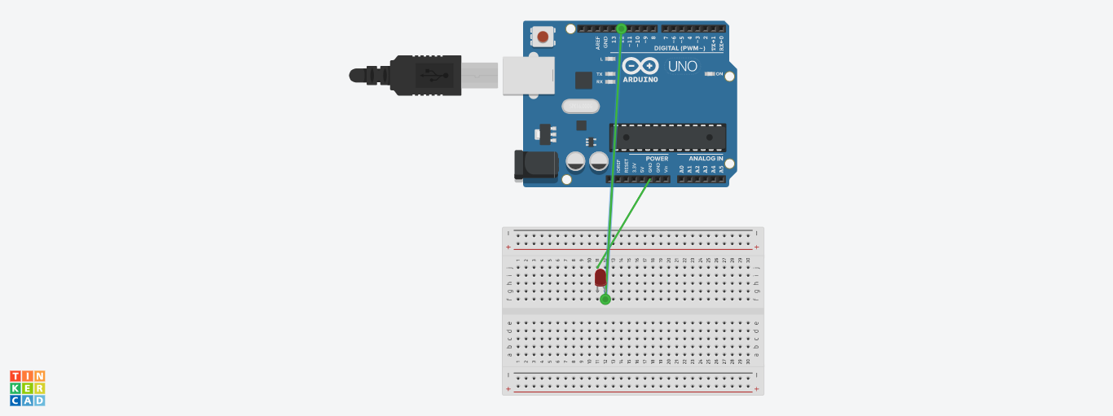

Theory

Concept Used: In led FLASHER, the led will glow and dim after few second.

Learning & Observations:

The led light will glow as shown like flash.

Problems & Troubleshooting:

1. Problem in fixing wire from bread board to Arduino uno.
2. Problem in writing Arduino uno programming.

Precautions:

1. Correct connection of negative and positive terminal of led.
2. Don’t put Arduino board near water.
3. Check the USB port of computer is working.
4. Check the Arduino software and select the correct port (in which Arduino is connected).

Learning Outcome:

1. LED light glow in the sequence of 12,8,5.
2. Arduino function as a controller in led chaser.
3. Bread board is used to organize the circuit.